 |  | 1 What two words make up these contractions?  can’t, it’s, I’ll, they’re, how’s, won’t | 2 Correct what is wrong with this sentence?  Mr brown is at are school?. | 3 Write a story problem that has the answer 17. | 4 Write the names of 2 fairy tales. What makes them fairy tales? | 5
6 | 7 Create your own homework. | 8 Write the number that is 20 less than the following: 43, 67, 94, 30. Challenge – can you do it? 487, 632 | 9 Which could you use to measure milk? Inches, gallons, quarts, miles. Tell why. | 10 How many different ways can you fold a square into fourths? Show it. | 11 What would you use to measure a football field? Inches, feet, yards, miles. Tell why. | 12
13 | 14  ENJOY YOUR | 15  SPRING BREAK! | 16  READ | 17  EVERY DAY! | 18 Count the number and types of birds you see in 10 minutes. Draw a picture of your favorite. | 19
20 | 21 Write the number that is 30 more than the following: 37, 55, 70. Challenge-can you do it? 856, 367 | 22 Draw 4 different shapes and then draw a line of symmetry on each. See how many lines of symmetry you can draw on each one | 23 Is Hey, Diddle Diddle a fairy tale, poem or nonfiction writing? How can you tell? | 24 Draw a clock to show 4:30. What time will it be in 3 hours, 5 hours and 7 hours? | 25 Which words have a long o? now, grow, rode. Which words have a long e? beet, great, easy. | 26
27 | 28 Write the words and tell how many syllables are in each: elephant, giraffe, zebra, bear, grasshopper, seal. | 29 What is the difference between a sphere and a circle? How are they the same? | 30 Name an insect that would make a good pet. How would you care for it? | 31 Grab a handful of coins. How much money do you have? Do it again. | Create your own homework. Yes, two times in one month!!!
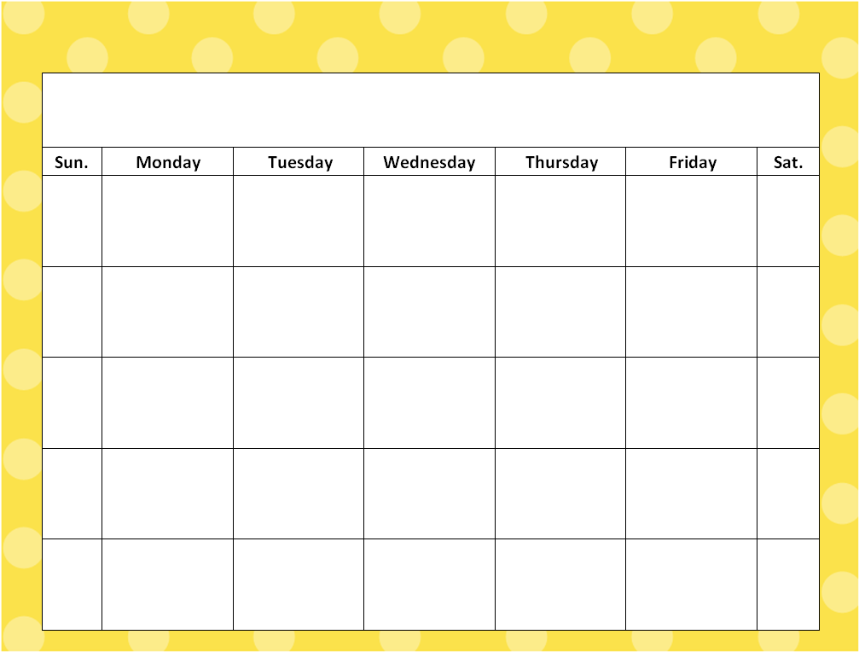
April
Read every night for at least 20 minutes. Keep track of all the books that you’ve read in your homework journal.

