 |  |  |  |  |  | 1
2 | 3 Write the name of the city you live in. Write a sentence about your city. | 4 Write the number that is 10 more than the following: 55, 73, 86, 94, 246 | 5 Write 3 equations and then show using the old switch-a-roo. Show how you solve the equations. (Toph) | 6 Tell an adult about Laura Ingalls. What is one thing you learned about living long ago?  Have the adult write the fact. | 7 Select a book. You read 2 pages and an adult reads a page. Take turns throughout the book. | 8
9 | 10 Write a question to your teacher. Ask her something you want to know. | 11 Trip is a word with multiple meanings. Write 2 sentences using trip. | 12 Draw a clock and show the time that you go to bed. How many hours do you sleep each night? | 13 Write the name of your state. Write a sentence about your state. | 14 Make a list of 10 things you own that are round. | 15
16 | 17 List 5 green foods that you like to eat. | 18 Select 2 potatoes. Make a ramp to roll them down. Predict which potato will reach the bottom faster. Record your results. | 19 Create your own homework. | 20 What is the name of the country you live in? Write a sentence about your country. | 21 Tell a family member three things you learned in school this week. Have that family member write it. | 22
23 | 24 What continent do you live on? Write a sentence about your continent. | 25 Choose a country on the map you would like to visit and write 3 sentences that tell why.  (Team F) | 26 What continent do you want to live on? Why? | 27 What time is it now? Draw a clock and record it. | 28 What is your favorite subject? Tell why.
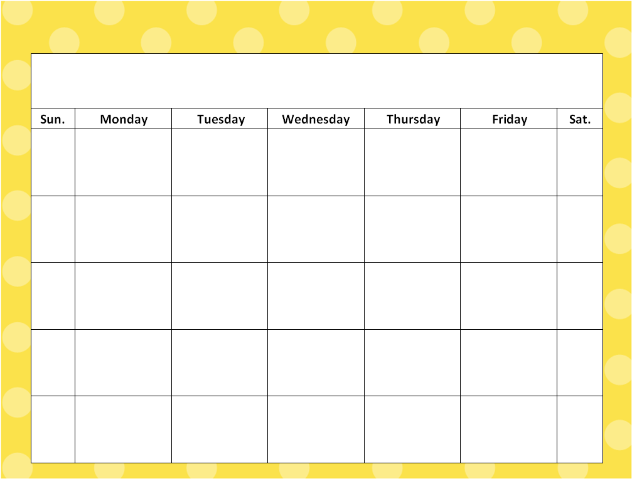
Read every night for at least 20 minutes. Keep track of all the books that you’ve read in your homework journal.
March

