|  |  |  |  |  |  |  |
| --- | --- | --- | --- | --- | --- | --- |
|  |  |  | **C:\Users\Angie\AppData\Local\Microsoft\Windows\Temporary Internet Files\Content.IE5\MHSV4WM7\MC900436236[1].png1** No School | **2** | **3**  **Read 20**  **minutes daily** | **4** |
| **5** | **6** Tally the weather conditions for each day this month: Sunny, Cloudy, Rainy, Snowy. | **7** Write out the steps you take to build a snowman. Use the words First, Next, Last, Finally. | **8**. Draw a picture of the snowman that you created in your writing. | **9** Draw 9 snowmen. Put a red or blue scarf on each. Write an addition story problem about it. | **10** Write a subtraction story problem about your snowmen. Solve the equation. | **11** |
| **12** | **13** Make a list of ways your family can save electricity and reduce your energy bills. | **14** Find a book about weather. Write the author and the title. | **15** What is the temperature today? How many degrees below or above freezing is it? | **16** Compare ice skates and roller blades. How are they alike and how are they different? | **17** Create your own science homework activity about motion. | **18** |
| **19** | **20** **No School**  Observe a  snowflake up  close. Draw a picture of what it looks like. | **21** How does winter weather affect the job of a police officer? Write 2 to 3 sentences about it. | **22** Is a sled easier to push or pull? Try it and write what you discovered. | **23** Place a cup of water outside overnight. Draw and write what you observed. | **24** Make a bird feeder from recycled materials. List and draw the different birds that visit it. | **25** |
| **26** | **27** Read the words below and write how they are all the same: bell, moss, tall, fizz, miss, call, buff, off | **28** List ways a meteorologist helps us plan our daily activities in the winter. | **29** Review your tally marks. Which weather condition had the most? Which had the least? | **30** Write a story problem using the data from your tally marks of the weather. | **31** How does winter weather affect the job of a construction worker? Write 2 to 3 sentences about it. |  |

**C:\Users\Angie\AppData\Local\Microsoft\Windows\Temporary Internet Files\Content.IE5\BI9K0S6F\MC900358691[1].wmf**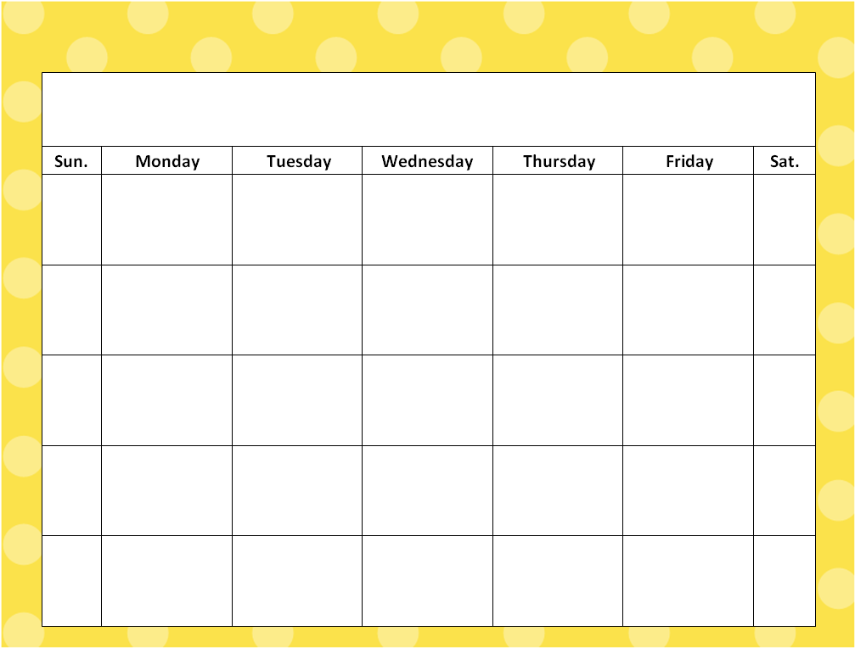

**January**