|  |  |  |  |  |  |  |
| --- | --- | --- | --- | --- | --- | --- |
|  |  |  |  |  |  | **1** |
| **2** | **3** Write your address. Be sure to include your city, state and zip code. | **4** Sort the numbers into two groups –  odd and even  23, 19, 44, 100, 97, 82, 38, 7, 59, 60, 1, 91, 28 | **5** Show 4 different ways to make $.62 using quarters, dimes, nickels and pennies. | **6** Read a story and tell an adult about the main characters. | **7** Select a book. You read a page and an adult reads a page. Take turns throughout the book. | **8** |
| **9** | **10** Count to 50 in Mandarin for an adult. Teach that person to count to 10 in Mandarin. | **11** Think of a number between 1-100. Make someone guess using less than/more than. What was your number? How many guesses did it take? | **12** Each cookie pan holds 12 cookies. If you have 4 pans, how many cookies can you bake at once? | **13** Make a map of a room in your house. Include a map key and compass rose. | **C:\Users\Angie\AppData\Local\Microsoft\Windows\Temporary Internet Files\Content.IE5\MHSV4WM7\MC900304919[1].wmf14** Make a list of 10 people, things or places that you love. | **15** |
| **16** | **17**  Count backwards from 100-1. Time yourself. | **18** Make a list of landforms that you have seen. Draw them. | **19** Read a nonfiction story. Write two facts that you learned. | **20** What is your favorite kind of weather? Write 3 sentences telling why it is your favorite. | **21** Interview a family member about their first grade experience. Make a T chart to compare first grade at CIS with their first grade experience. | **22** |
| **23** | **24** Make a list of your 5 favorite books. Write a sentence to tell why each book is your favorite. | **25** Choose a state on the map you would like to visit and write 3 sentences that tell why. | **26** Write the names of the streets around CIS. | **27** Write a subtraction story problem about the students in our class. | **28** Why are maps important in our daily life? Write to explain why. |  |

****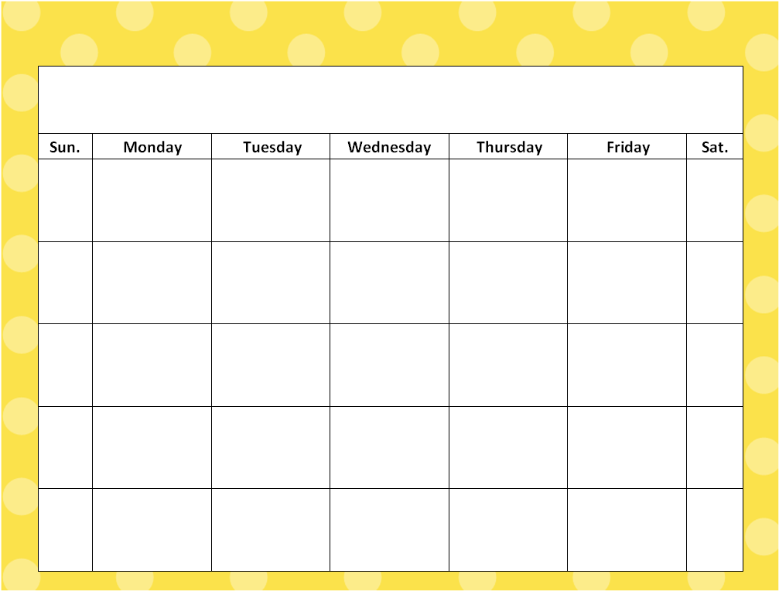

**Read every night for at least 20 minutes. Keep track of all the books that you’ve read in your homework journal.**

**February**